Fully Convolutional Networks

Typical Convolutional Networks (For Image Classification) Contain a series of convolutional layers, followed by fully connected layers and then a softmax activation function.

This is great for classification of things like is this a picture of a hotdog, but what if we want to change our task slightly to answer where in this picture is the hotdog.

Fully Connected Layers dont preserve spatial information, and therefore lose the required info.

It turns out that if we change our Fully Connected layer to a Fully Convolutional Layer, we can integrate convolutions directly into the layer, and keep spatial information.
Spatial information is maintained throughout the entire network.

Because convolutional systems dont fundamentally care about the size of the input, this network will work for images of any size.

A Convolutional Neural network image size is constarined by the size of the fully connected layers.

After our convolutional layers, with an input image of different sizes, our output will be of different sizes as well, which doesn’t work well with Matrix multiplications.

Fully Convolution Networks have achieved state of the art results in computer vision tasks, such as Semantic Segmentation.

FCNs take advantage of 3 special techniques:
1) Replace fully connected layers with 1x1 convolutional layers
2) Upsampling through the use of transpose convolutional layers
3) Skip Connections to allow the network to use information from multiple resolution scales.

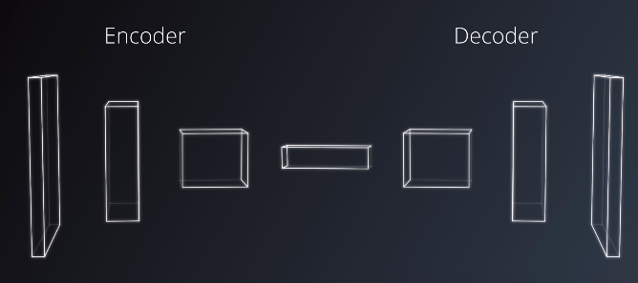
An FCN is composed of a Encoder and a Decoder.
Encoder here is a series of convolutional layers, (Like the ones in VGG and RESNET).
The goal of the encoder is to extract features from the Image.

The Decoder is used to upscale the output of the Encoder such that it is the same size as the original image.

Step 1: Replacing a Fully Connected Layer with 1x1 Convolutions

This results in an output value where the tensor remains in 4D instead of getting flattened into 2D for a fully connected layer.

This way, spatial information is perserved.

Recal:
Output of a Convolution layer is the result of sweeping the Kernel over the input with a sliding window and performing element wise multiplication and summation.

One way to think about this is the number of Kernels is equal to the number of outputs of a Fully Connected Layer.
Similarly the number of weights in each Kernel is equivalent to the number of inputs in the fully connected layer.

*See quiz for example*

Step 2: Upsampling using Transposed Convolutions

It is escentially a reverse convolution where the forward and the backward passes are swapped.
It is called the Decoder because it undoes the previous Convolutions. The math here is actually exactly the same as what we do for the Encoder.
The Property of Differentialablity is retained, and thus training is simply the same as previous neural networks.

*See quiz for example*
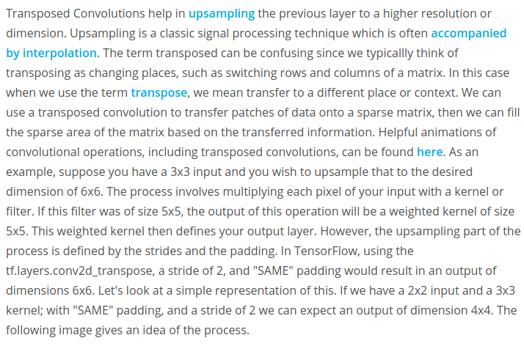
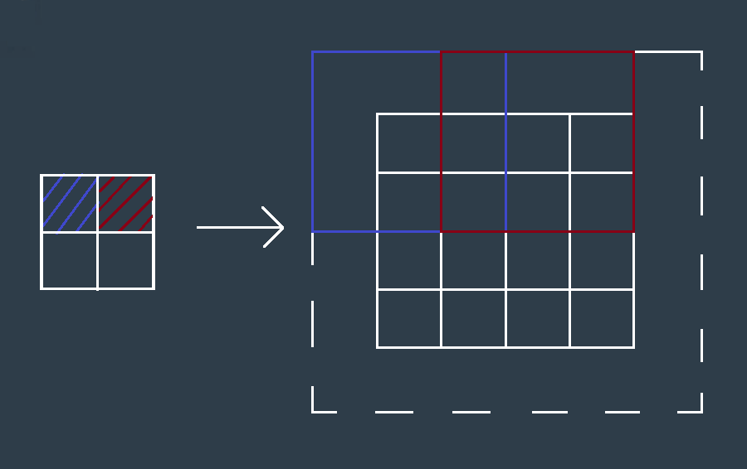

Step 3: Skip Connections

One effect of the Convolutional layers, or encoding in general, is narrowing down the scope by looking at finer and finer details/features in later convolutional layers, and lose the bigger picture.

This means that even if we were to decode the encoded image back to the original image size, some information is still lost. Skip connections are a way to retain the information easily.

Skip connections work by connecting the output of one layer to a non adjacent layer.

Ex. The output of a pooling layer from the encoder is input to the equivalent layer at the output.

Skipped connections let the network use information from multiple resolutions.

As a result, the network is able to make more percise segmentation decsions.

Adding too many skipped connections can lead to having a model size that is much too large.

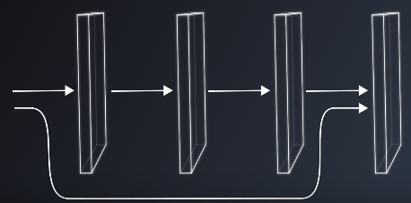

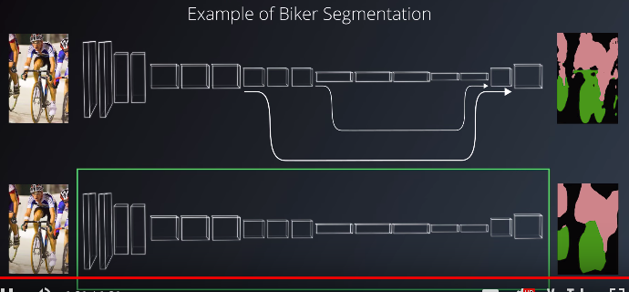

Using FCNs in Practice

FCNs have 2 components the Encoder and the Decoder.

The encoder extracts features that will later be used by the decoder, which sounds similar to transfer learning.

We can borrow techniques from Transfer Learning to accelearte the training of our FCNs.

It is very common for the Encoder to use a pretrained model like ImageNet or VGG or RESNET.

Too many Skip connections shouldn’t be used due to the size of the model growing.

Example:
When using VGG 16 as the encoder, only the 3rd and the 4th pooling layers are typically used for skip connections.

